Library Management System – Book Return

This mini project is one of the modules created for Library Management System using ABAP on SAP. This module is for returning a book to the library which was issued to a library user.

# Created By

Group – 3 (Library Management System)

# Assumptions

* Only Admin has the right to perform book return transaction on the database.
* The admin has already logged into the system.
* Book issue was done in a separate module independently.
* In case of overdue in book return, fines are taken care of by another module.

# Functionalities

* Admin can see all the books which are issued at that time.
* Admin can see the details of the user to whom the book is issued.
* Admin can return a book by providing its Book-ID.
* Admin can head to return a book straight from the list of all issued books.
* Admin can return multiple books issued to a single user in one go, providing the User-ID of that user.
* Admin can return multiple books issued to different users in one go providing all the Book-ID’s.
* Admin can see the book return history (transactions).
* Admin can filter the transaction history by User-ID and/or time period.

# Screens

1. Main Menu: This is the home screen for this module of book return, having all the functionalities as:

* Return Book (Goes to screen 2)
* Display All issued books (Goes to screen 3)
* Book Return History (Goes to screen 4)

1. Book Return: This screen is having all the options to return a book as:

* Book return by Book-ID (On the same screen)
* Book return by User-ID (Goes to screen 5)
* Multiple Book return by Book-ID’s (Goes to screen 7)

1. All Issued Books (OOALV): This screen has an interactive ALV with the following functionalities:

* Shows the list of all books which are issued at the time of display (On the same screen)
* Double click on the Book-id shows corresponding book user (Screen 6 pops up)

1. Return History: This screen prints the previous transactions of book return this screen has:

* Filters to restrict the return history output (On the same screen)
* Adobe form to print the history (Popup)

1. User Issued Books

* This screen is called when the user chooses to return the book given a user id.
* This is useful when we want to return multiple books which are issued to a single user.
* We can select multiple books at a time and return in one go (DML on table control)

1. User Details

* This Screen is called when the user double clicks on any book id from the ALV screen.
* This is a popup screen which shows the details of corresponding book user.

1. Multiple Books Return

* This screen is called when the user chooses to return multiple books at a time which are issued to different user.
* Here the user does not have to repeat the process of returning a single book many times.
* Multiple Book-ID’s can be given in comma separated format
* We can select multiple books at a time and return in one go (DML on table control)

# Tables

1. Books Table

* Book-ID
* Book Title
* Book Author
* Book Issue Flag (Boolean Flag)
* Book User (if flag = 1)

1. Users Table

* User-ID
* User Name
* Other User Details

1. Return Transaction Table

* Book-ID
* User-ID
* Return Date
* Return Time

# Search Help

1. For Book-ID (all issued books id and title)
2. For User-ID (all user with user id and name)

# Functionality Navigation

The navigation to all the functionalities of this module is provided with screen shots.

Main Menu

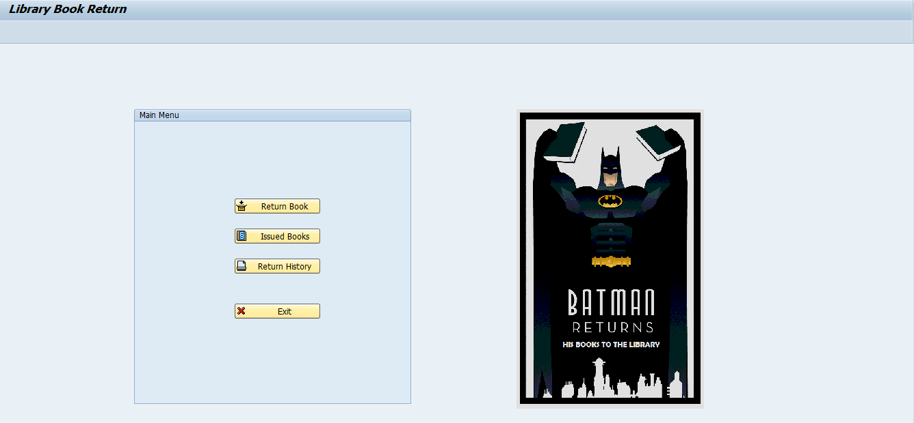

Main Menu → Book Return → Book-ID

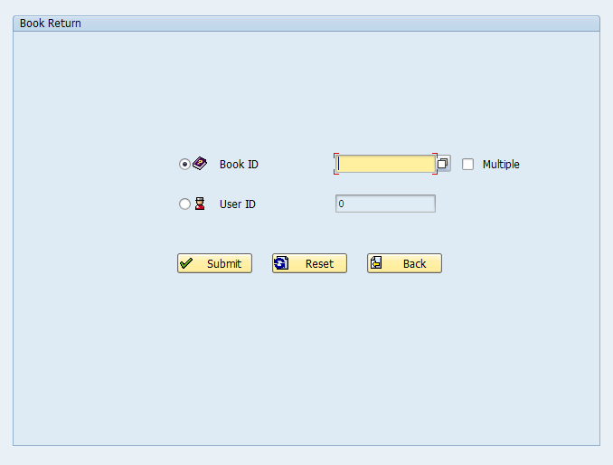

Main Menu → Book Return → Book-ID → F4

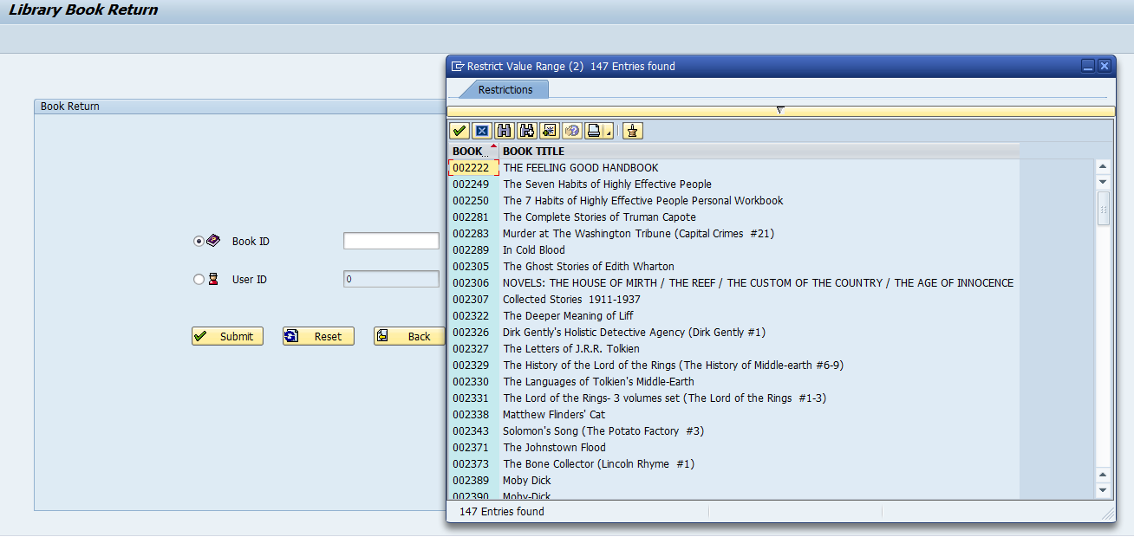

Main Menu → Book Return → Book-ID → Submit

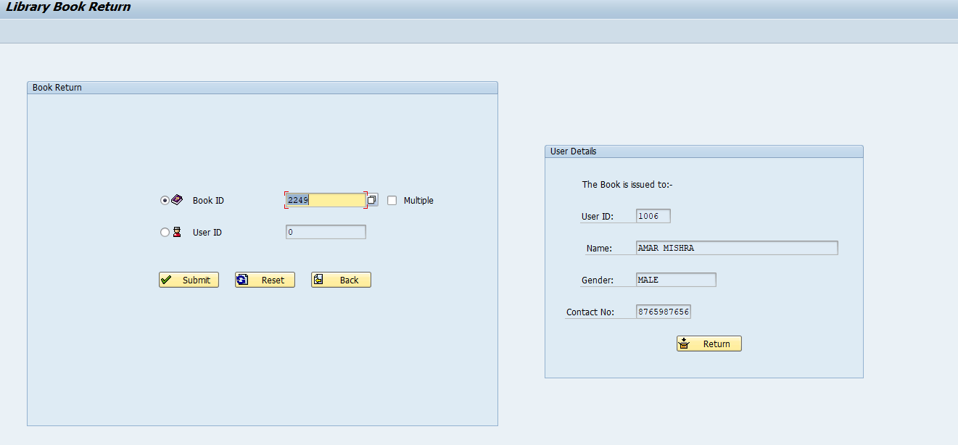

Main Menu → Book Return → Book-ID → Submit → Return

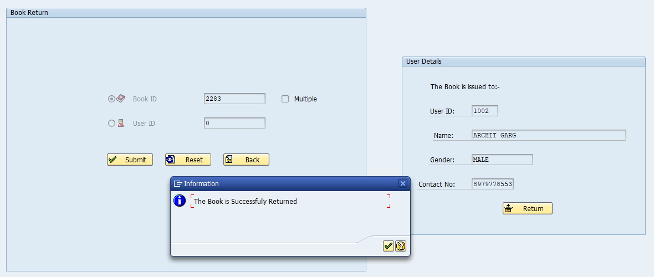

Main Menu → Book Return → User-ID

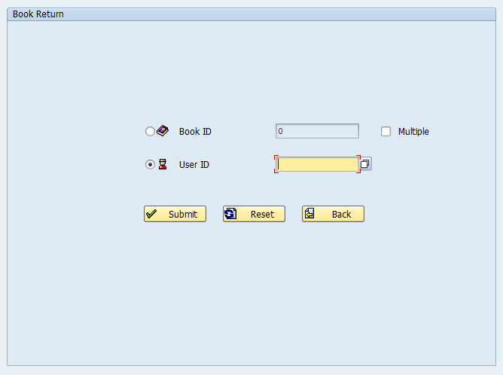

Main Menu → Book Return → User-ID → F4

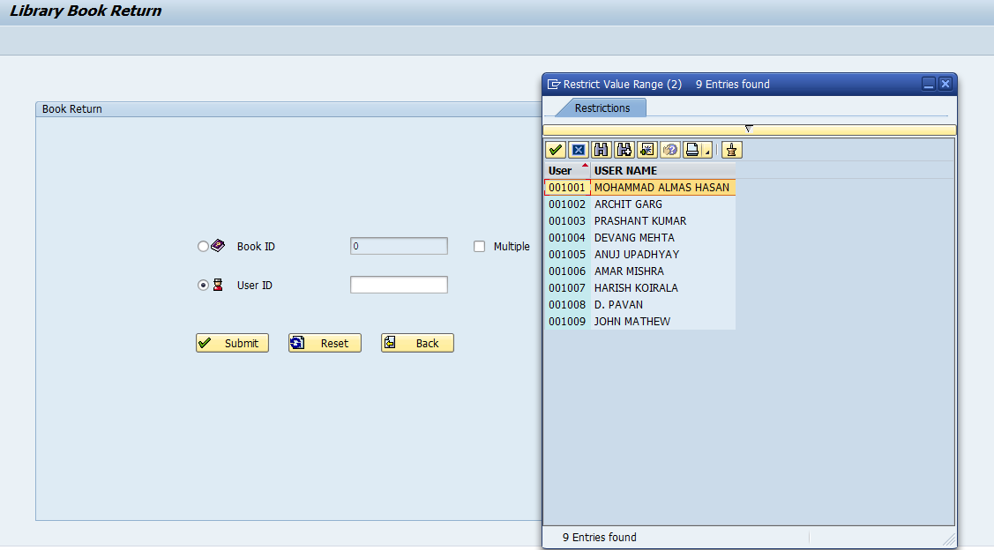

Main Menu → Book Return → User-ID → Submit

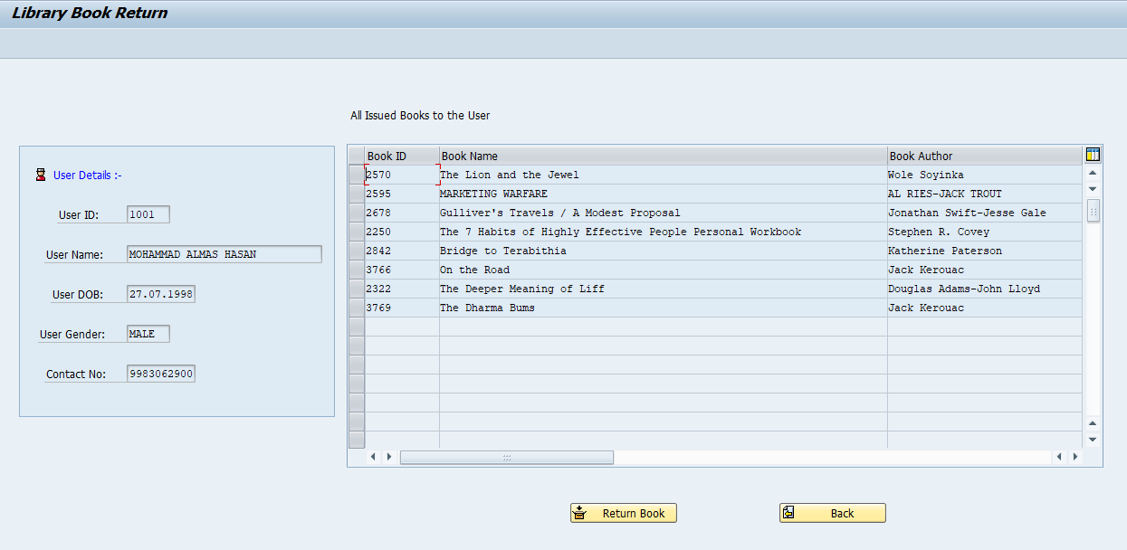

Main Menu → Book Return → User-ID → Submit → Return Book

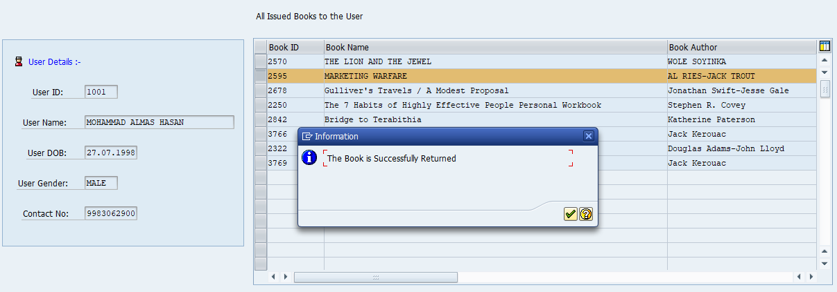

Main Menu → Book Return → Book-ID → Multiple

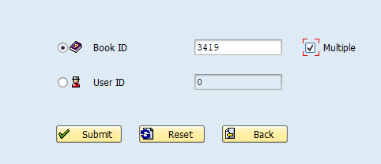

Main Menu → Book Return → Book-ID → Multiple → Submit

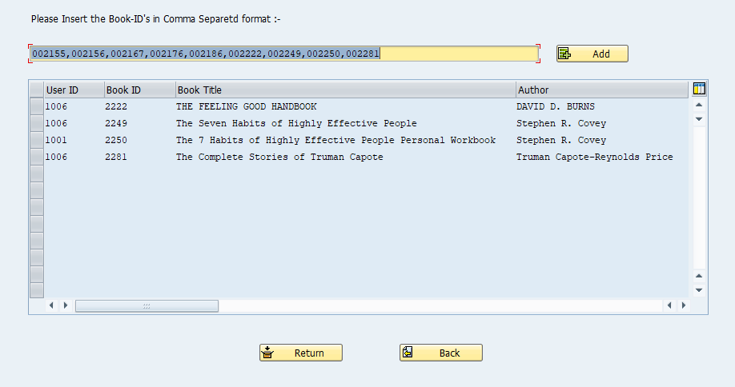

Main Menu → Book Return → Book-ID → Multiple → Submit → Select → Return

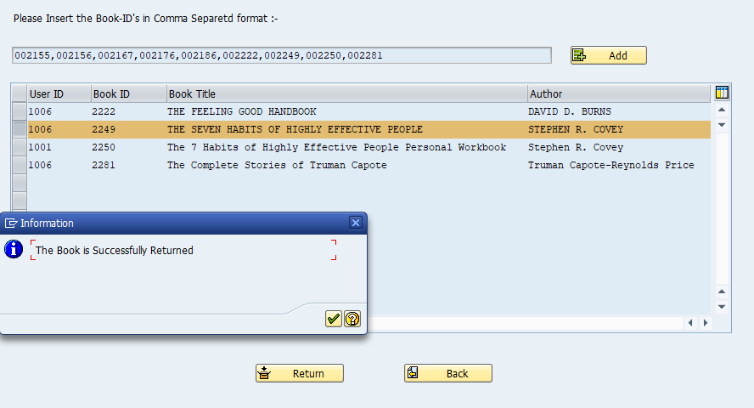

Main Menu → Issued Books

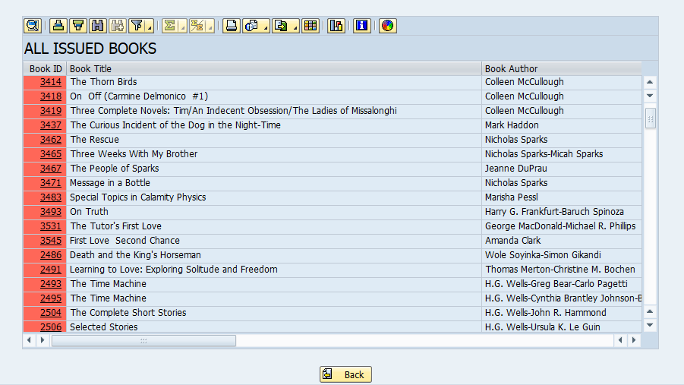

Main Menu → Issued Books → Double click

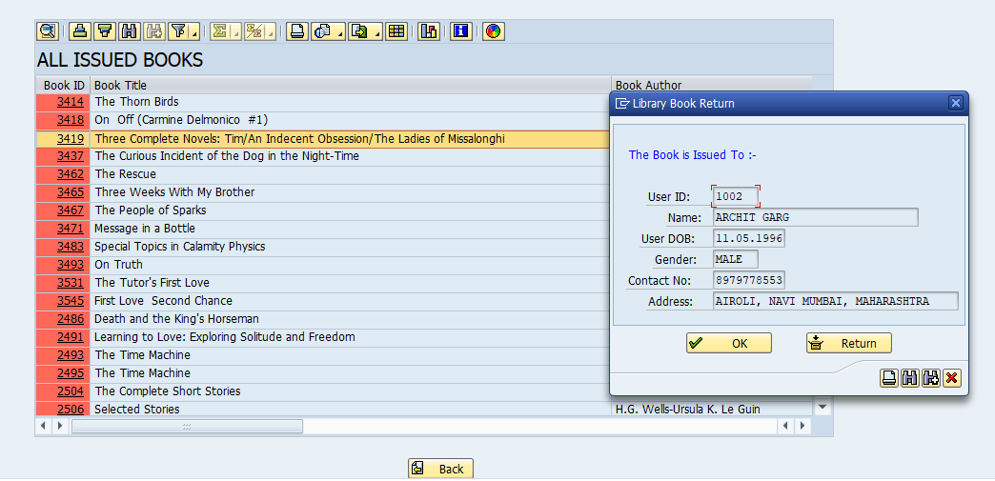

Main Menu → Issued Books → Double click → Return

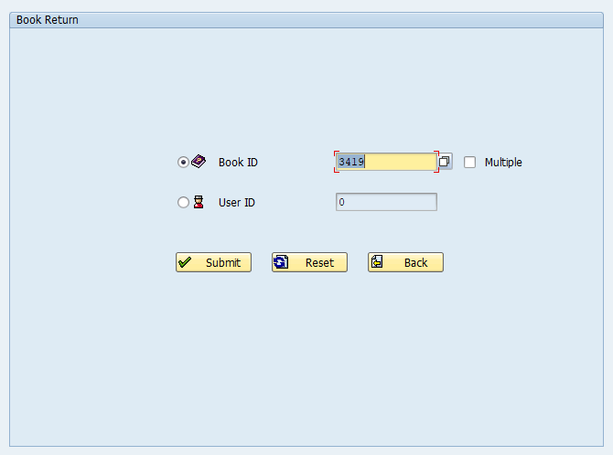

Main Menu → Return History

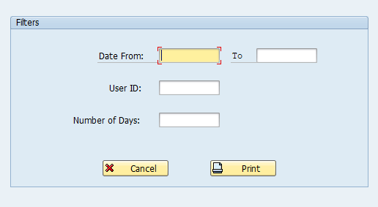

Main Menu → Return History → Print

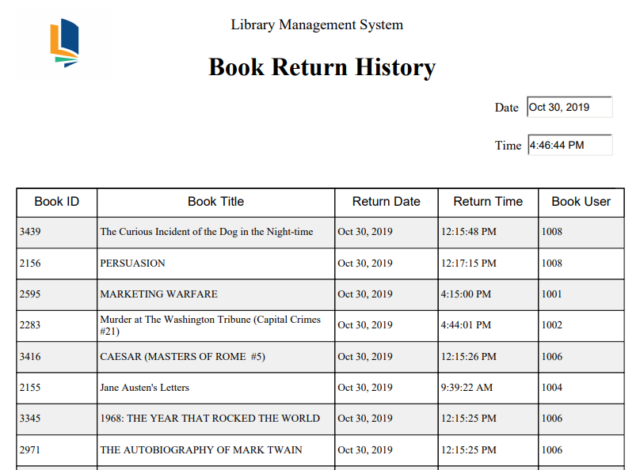

# Appendix – Tables (Screenshots)

Book Table:

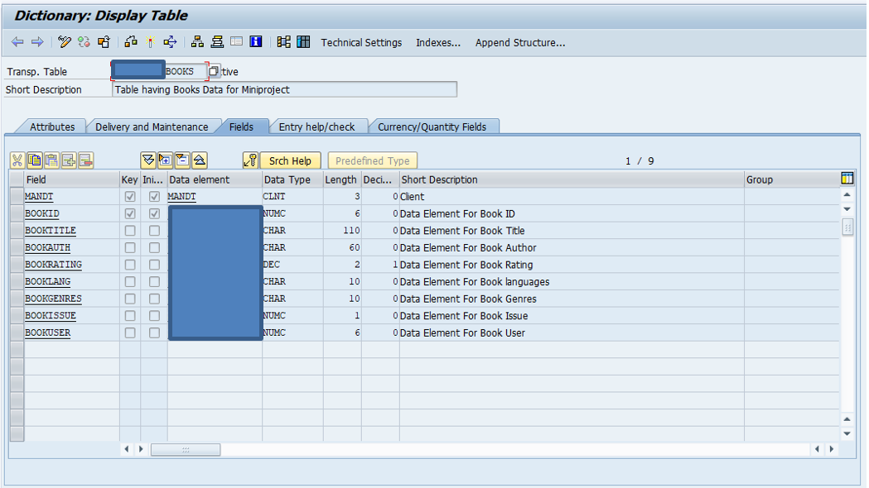

User Table:

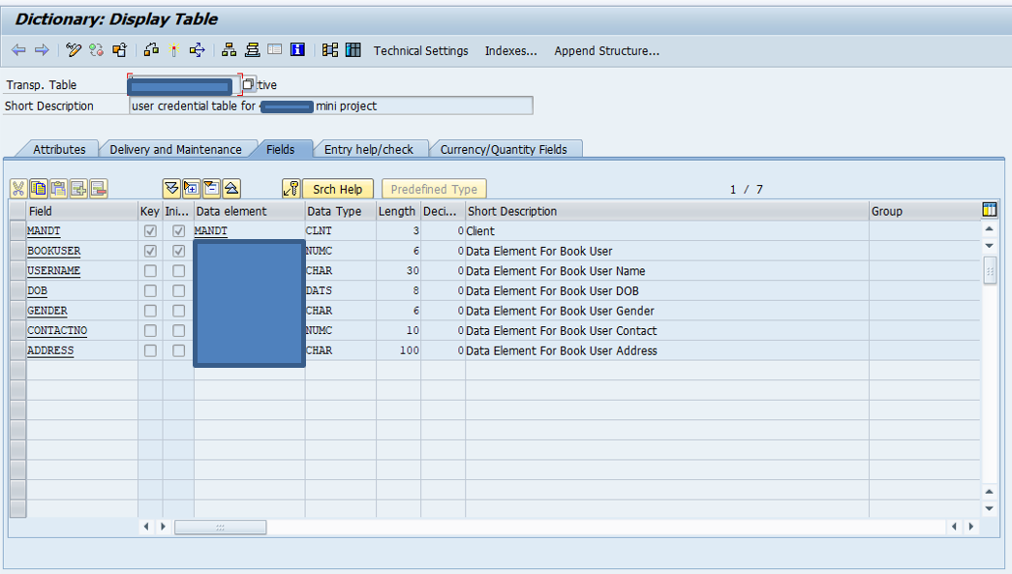

Return Transaction Table:

